CONTENTS
1.0 Purpose 2
2.0 Scope 2
3.0 Reference Documents 2
4.0 Overall Description 3
4.1. Overview of products/processes 3
5.0 Business Requirements 5
5.1. Consolidated USB Requirements 5
5.2. Summary of Gap analysis/decisions 11
6.0 Software features 16
6.1. User Roles and security 16
6.2. Operating environment 16
6.3. Design and implementation constraints 16
6.4. User documentation 16
6.5. SOX/QSR validation 17
7.0 Assumptions and dependencies 17
7.1. JDE -Product Data Management 18
7.2. JDE-Standard costs & category codes 18
7.3. JDE- Financial setups for costing for PTB-CA 18
7.4. Major Cross-functional responsibilities 19
8.0 Applications and Reports 19
8.1. Changes to applications 19
8.2. Field level mapping and definitions for PDM applications (USB requirement) 20
8.3. Reports 22
8.4. Data Conversion (Open Balances) 22
8.5. Data Conversion (Master Information) 23
8.6. Project Documentation: Please review at the project SharePoint site. 23
8.7. Training 23
9.0 Other Requirements 23
10.0 Appendices 23

Revision | Submitter | Department | Comments | Date
1 | Mathur Ravikumar | IT-Apps | Initial version | 1/27/2010
Sign-off Sheet
 | Name | Department | Signature & Date
Approver (IT) | Prakash Doddabele | IT-apps
Approver (IT) | Scott Jablonski | IT
Approver (business) | Derek Daley | Costing/ Finance
Approver (business) | Amy Nasr | QA & RA
Approver (business) | Charlie McBride | Operations
Approver (business) | Ron Fitzgerald | Operations

Purpose
The purpose of this document is to describe how the Affymetrix-USB (building1 & building 2 in Cleveland, Anatrace facility) manufacturing activities will be handled and processed in JD Edwards One World ERP system as a part of integration from FourthShift (FS) to JDE. The functional areas include product data management (PDM-item master, itembranch, bill of materials, routing), to work order processing, inventory management and manufacturing accounting.

Scope
Current business processes within JDE is being expanded to cater Affy-USB requirements. Major differentiators are,
- USB manufacturing data is kept in Cleveland FS instance, Anatrace FS instance and Sage Officeline for Germany. All data will get merged into Corporate JDE instance.
- USB Cleveland and USB Anatrace will come under JDE branch 1003 (company 10) and GmbH will move into branch 6130 (current UK inventory branch)
- Major process changes and field level requirements are listed later in this document

Reference Documents
- User requirement gathering and gap analysis: USB-JDE IntegrationALL.xls
- Summary of gap analysis and solutions: Proj USB integration PTB-CA details Jan2010.ppt
- Detailed documentation on the solutions: Proj USB integration PTB_CA JDE process screenshots Jan2010.doc

Overall Description

Overview of products/processes
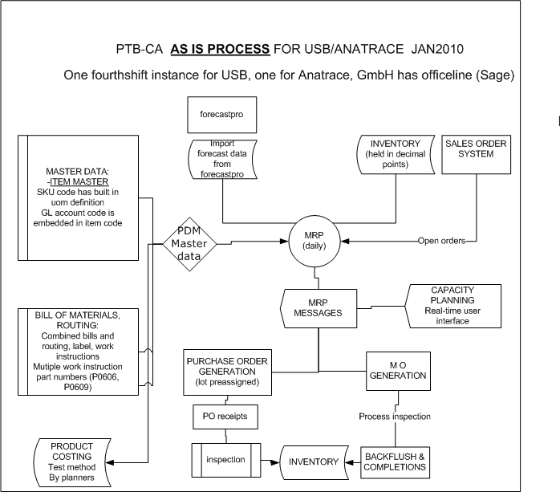

To be process

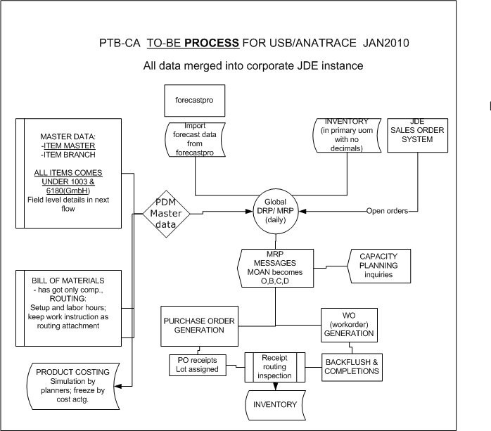

Business Requirements

Consolidated USB Requirements
Please refer to USB gap requirements and decision points excel sheet in SharePoint. Summary of the gaps is available under Proj USB integration PTB-CA details Jan2010.ppt
Item master | Upload Fourth Shift item data into JDE. GmbH data will be from office line system. Create itembranch records.
Bills | FourthShift has combined bills, routing and text instructions. These are to be loaded into JDE for cutover. USB will split the text instructions separately and consolidate multiple routing hours, if applicable.
Forecasting | USB uses forecastpro (bolt-on to FS) to generate forecast from sales history. For this project, this forecast data need to be imported into JDE forecast.(for use in MRP run).
Lot control | USB has global and local lot counter functionality. JDE has one single lot number definition. USB will use JDE lot trace/track functionality. Existing item numbers from FS need to be imported with the current lot numbers. Future transactions will handle JDE lot numbering (manual for PO receipts, work order number as lot number for manufacturing)
Capacity planning | FS capacity planning functionality is used at USB. JDE functionality on this area (with no real-time scheduling) will be implemented as a part of this project
Doc control | Planning or materials create new part numbers in FS. We will use mass upload to transfer current data from FS to JDE (both for items and bill/routing). After go-live, formal FM086 process will be used to add/modify item numbers. Affy process will be used to add/modify bills/routing.

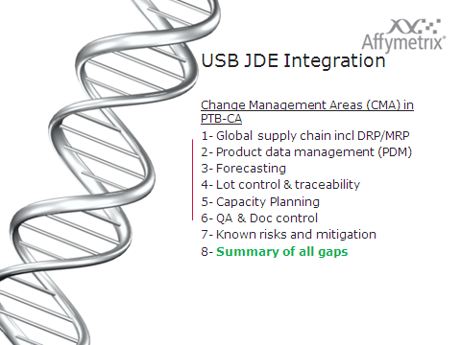

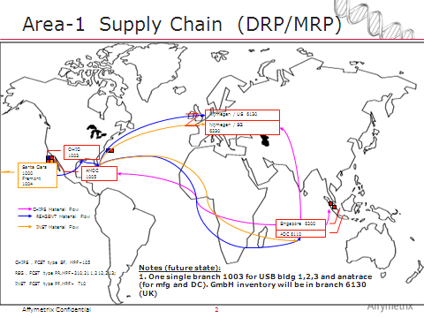

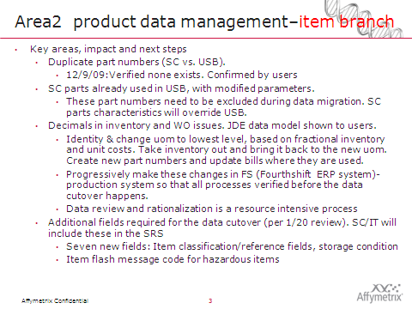

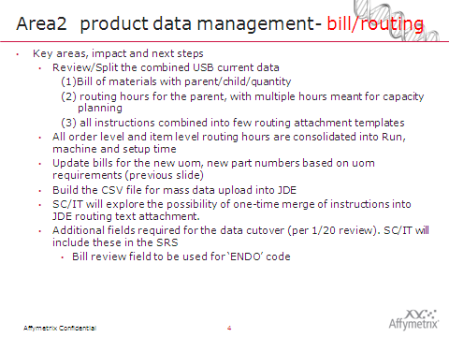

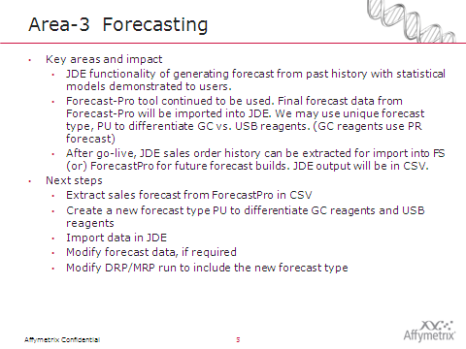
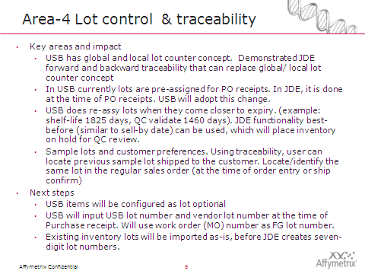

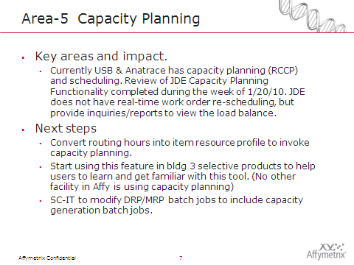
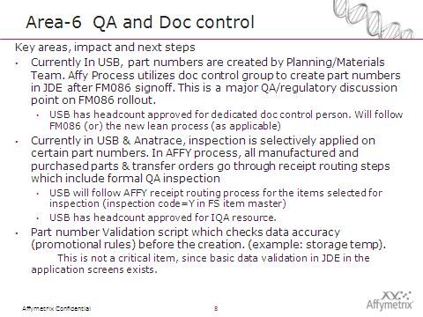

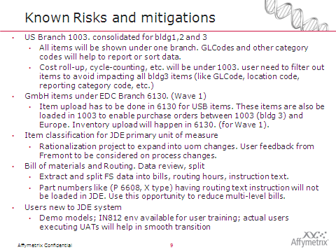

Summary of Gap analysis/decisions
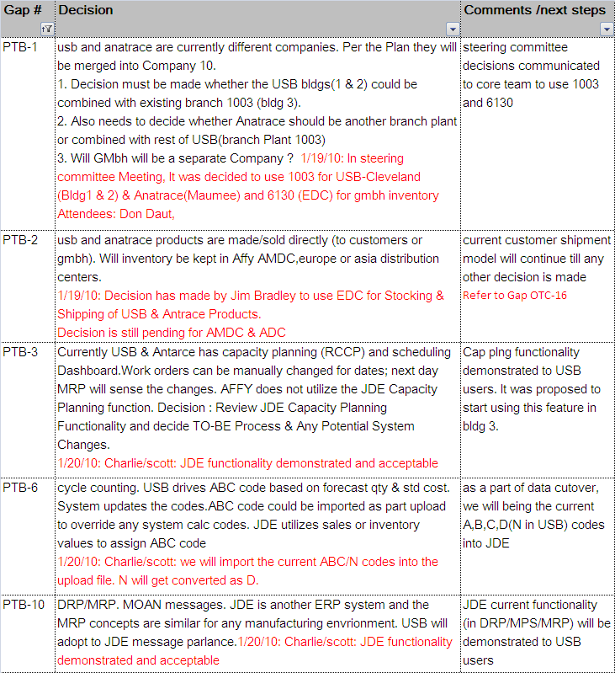

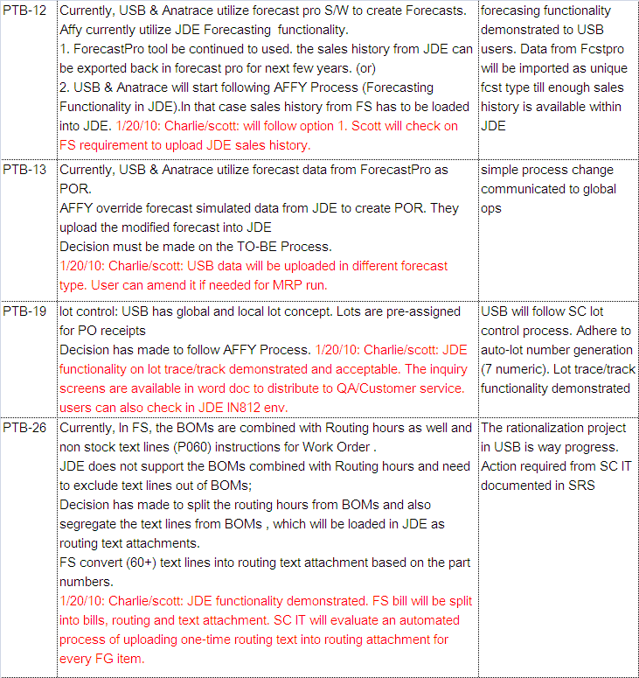

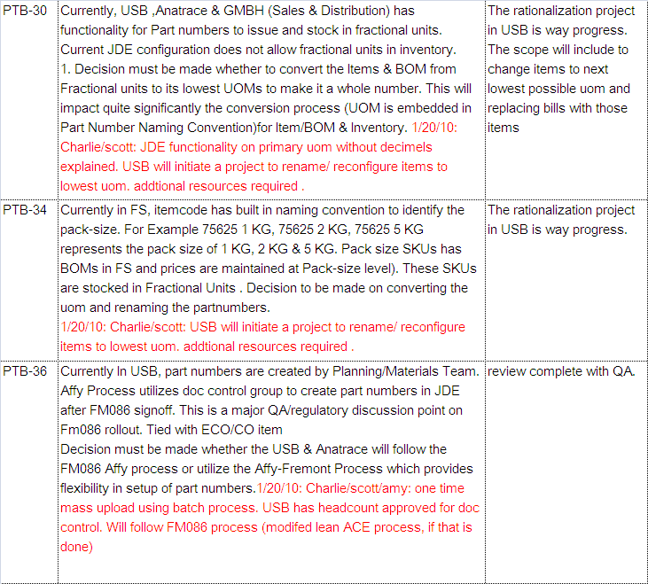

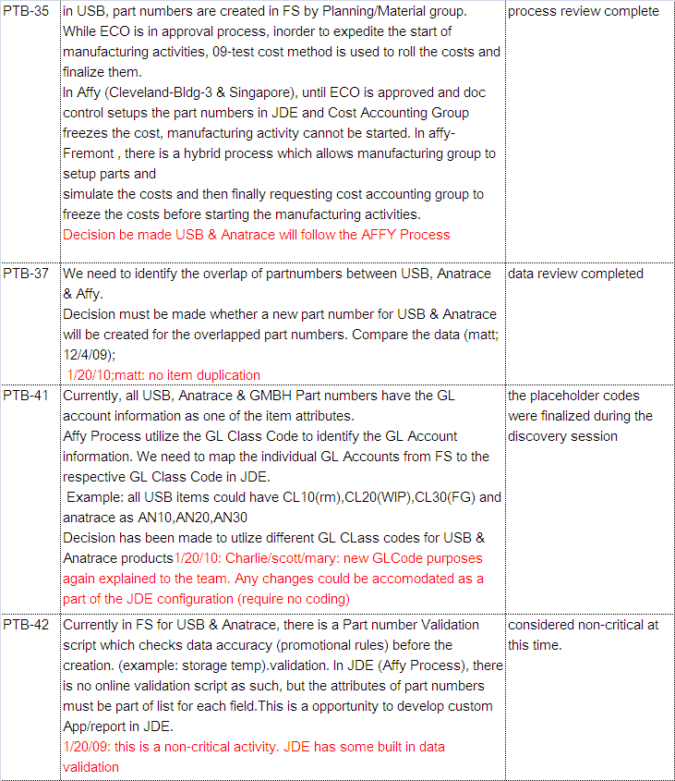

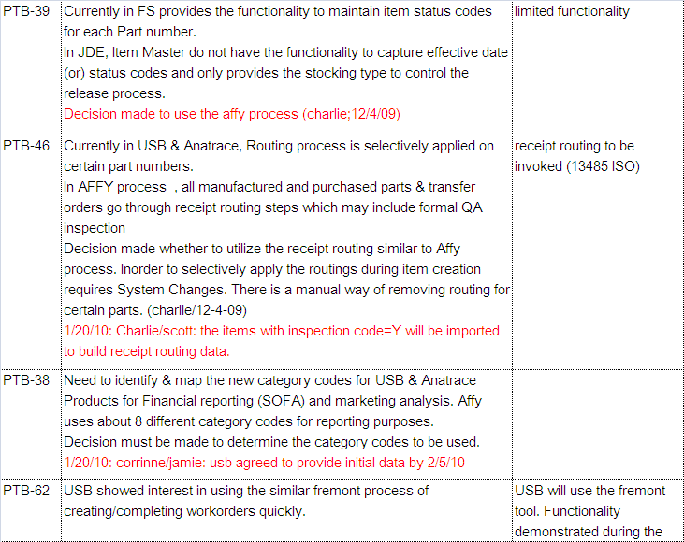

Software features

User Roles and security
All the business users (in building 3) having access to JDE system will continue to use the same features for the affy-USB
Following roles will be used to identify and assign resources based on SOX review.
  - R&D/Doc control PD3
  - Shop floor control SF3
  - Cost accounting CA1
  - Material movements IC1
  - Purchasing PU3
  - Quality Assurance QC1/QA1
  - Planning PL3
The new user account creation in JDE will follow the current workflow in affy intranet site.

Operating environment
All transactions in Fremont will be done in our current JDE 8.12 Production environment as that being used currently at Santa Clara. No separate installation of JDE production server and/ or production environment is envisaged for this project. For testing & user training, there will be a separate environment available. (Example: IN812). The data in IN812 will be refreshed from production system on need basis.

Design and implementation constraints
- All JDE configurations has to be entered in IN812 environment first for unit testing/UAT testing and finally entered again in PD812 for production system. Data integrity has to be maintained to get sustained results.
- JDE Software deployment to PD812 environment is frozen (black-out) during month/quarter ends and first few weeks in the beginning of the month/quarter. This may necessitate re-scheduling of the package builds to suit project go-live dates.

User documentation
Business owners will use DoPs and will use existing JDE documentation for user training. Some of the documentation in bldg1 & 2 need to be updated as a part of QSR validation. This includes DoPs, work instructions, training records.

SOX/QSR validation
There will be a validation phase before go-live period, to validate the system for SOX, QSR, FDA and ISO regulatory requirements. The project plan will have the details on the schedules. Please see appendix-5 for QSR impact area analysis.

Assumptions and dependencies
Assumptions:
- For data cutover, Affy-USB will follow the item upload process instead of Form 086 process. QA will review and formulate change management on this new process. From the system point, there will be a new custom PDM (product data management) interface created for this purpose. After go-live, new item number creation or modifying existing item numbers will follow FM086 process.
- Affy-USB will require a manufacturing back-flush process for issue of RM and bringing FG into stock, without the need to go through all the work order steps. We intend to use the custom application created for Fremont facility.
- All raw materials, consumables and finished goods will be kept in Affy-USB site (branch 1003). FG will be available at USB and not in AMDC (decision as of Jan 10). All inventory in GmbH will be moved UK branch 6130.
- Part numbers and inventory is maintained in FS for USB items will be carried over to JDE. There are no overlapping item codes. Current Affy items in FS need to removed before upload. All USB items configured as P-purchase items in JDE need to be modified as M –manufactured item, to enable complete cost roll/MRP run.
- Currently Affy Corporate does not use Capacity Planning functionality. As a part of this implementation, basic capacity planning functionality like work center messages, load review, etc will be executed for USB. MPF (master planning family) codes will remain same as in other reagent products.
Dependencies:
All the related order-to-cash and accounting setup are to be in place before the Sales orders, purchase orders and work order generation starts. All new category codes (marketing/finance) are to be uploaded in the system to make financial reporting effective.
SC-IT is in the process of updating the JDE toolset to the next level.

JDE -Product Data Management

Item master | As a part of data conversion, the item master data will be converted from Fourth Shift to JDE (using data upload tool). On a daily basis (for new products and modifying the current data), users will follow Affy FM086 /FM120 process
Item branch plant | It is intended to use 1003 for the entire USB facilities. This includes all US based locations (bldg 1, bldg 2, Anatrace). The data upload tool will handle the itembranch creation as well, during the data conversion.
Item branch location | New locations will be added for each of the buildings. There could be specific naming conventions before the upload to identify and process data quickly.
Bill of materials | As a part of conversion, the bills data will be converted from Fourth Shift to JDE (using data upload tool). On a daily basis, the new bills will come thru doc control process
Routing | As a part of conversion, the routing data will be converted from Fourth Shift to JDE (using data upload tool). On a daily basis, the new routing will come thru doc control process

JDE-Standard costs & category codes
Purchased standard | PDM interface will transfer data from csv file (FS upload file) into JDE
GL category code | There will be new GLCodes like CL10(raw materials),CL20(intermediate or WIP) and CL30 (finished goods). Anatrace will use AN10, AN20, and AN30. These are placeholder codes. USB will add or modify these codes before the UAT1 timeline.
Marketing category codes (also used in SOFA apps) | The codes required have been discussed and documented. Affy USB needs to update the csv file to reflect these new codes.  Business Area (SRP1); Product line (SRP2), Product Type (SRP3), product family (SRP7), product subfamily (SRP8), product category(PRP2), vertex (SRP6)

JDE- Financial setups for costing for PTB-CA
FG standard cost | All the costs are to be rolled in the 1003 branch plant. Cost need to be copied into 6130 for GmbH
GL cat code | There will be new GLCodes like CL10(raw materials),CL20(intermediate or WIP) and CL30 (finished goods). Anatrace will use AN10, AN20, and AN30. These are placeholder codes. USB will add or modify these codes before the UAT1 timeline.

Major Cross-functional responsibilities
Business area | Activities
Doc Control, QA, Planning | All PDM data update (one-time upload) will go thru interfaces instead of manual FM086 form. All QSR and process validation need to be reviewed and updated procedures are to be in place before the UAT start.
Supply planning | Forecast data from ForecastPro will be imported into JDE as a part of cutover. User can modify and maintain the forecast data with JDE for incremental changes. This data will be used for MRP. Proposed to use different forecast type (PU) to differentiate GC reagents and USB reagents.
Cost accounting | Standard cost simulation and cost freeze has to be done for all applicable products. For Wave 1, USB cost will be imported directly into GmbH and 1003 (building 3) branches. For Wave 2, the cost roll-up for manufactured parts has be done and copied across DCs.
Material and Logistics | The inventory transfer from FS to JDE will have lot identified products. These lot number will be maintained as-is in JDE system. Future receipts from go-live will follow next numbering or work order numbering as per item configurations for lot control. Expiry date, sellby date and best before date will be used

Applications and Reports

Changes to applications
- PDM upload interface. Item upload -modified to include additional codes for USB; bill upload- modified to include additional fields for USB. Media attachment upload- new to convert text items into media attachment in item routing.
- Manufacturing back-flush interface. Modified to exclude inventory going negative and get lot number as work order number.
- Other reports & Queries. See last section

Field level mapping and definitions for PDM applications (USB requirement)
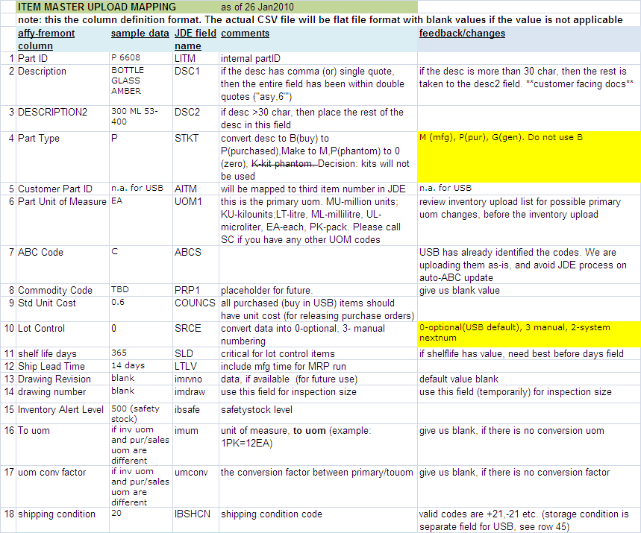

ITEM UPLOAD..CONTINUED
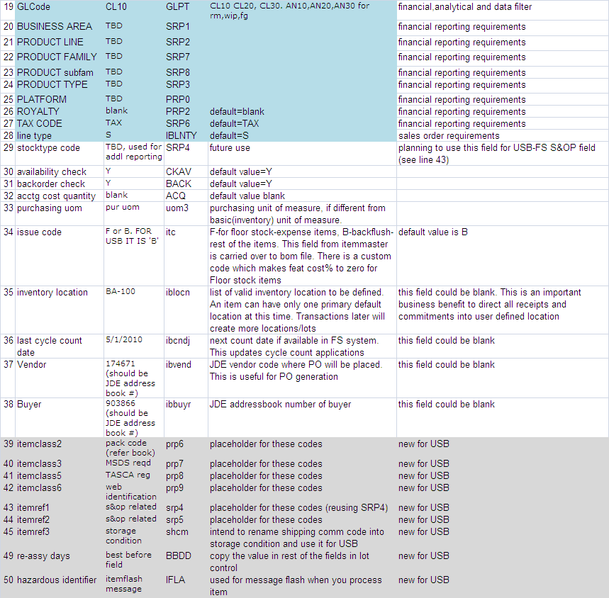

BILL OF MATERIALS AND ROUTING

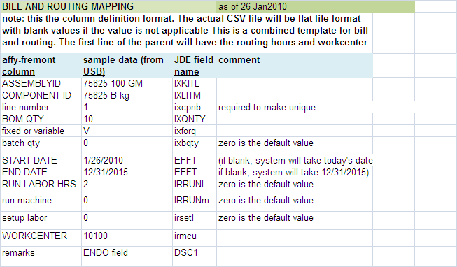

Reports

Standard JDE Reports

All the current JDE reports need to be updated with additional data selection for the branch plant (as applicable)
USB will use the current Affy work order report (replacing the MO format)

Custom New Reports

1 SARA report (build custom item/material matrix, calculate the values based on current inventory. Used by QA for material reporting to Govt agencies

2 Capacity analysis (dispatch list) reports.

3 Summary of daily MO or purchase orders released.

Data Conversion (Open Balances)

Beginning inventory: inventory balances will be uploaded into system thru positive inventory adjustment during go-live week. This is applicable both for FG and raw-materials/intermediates

Open work orders: Backlog orders will be executed in the FS system, to the extent of available inventory. Rest of the orders (MO in FS parlance, work orders in JDE) need to be re-entered in JDE system (new work order number, manufacturing documentation).New work orders will be created in JDE system.

Data Conversion (Master Information)

Item Master, Item branch: data conversion thru the PDM interface

Bill of materials, routing: data conversion thru the PDM interface

New standard costs: After data conversion, cost accountings have to roll the standards. (Simulation and cost freeze)(To validate all bom quantities and labor hours/rates). There will be new generic work centers with labor rates defined.

Project Documentation: Please review at the project SharePoint site.
USB project SharePoint LINK

Training

End User Training
Power user will be conducting on-site orientation and training the new users. DoPs and available training documentation will be used.

Other Requirements
Test Scenarios: IT will prepare separate test scenario documentation for validation and user sign-off.
Final summary report will be created as part of deliverables.
All key decisions are documented under decision log document (available in project SharePoint site)

Appendices
APPENDIX -1 key JDE configurations
APPENDIX -2 changes required to batch versions/reports
APPENDIX -3 high-level UAT (user acceptance testing) scope
APPENDIX -4 JDE –ISO-QSR IMPACTED AREA

Appendix -1 JDE configuration is IT business analyst’s responsibility
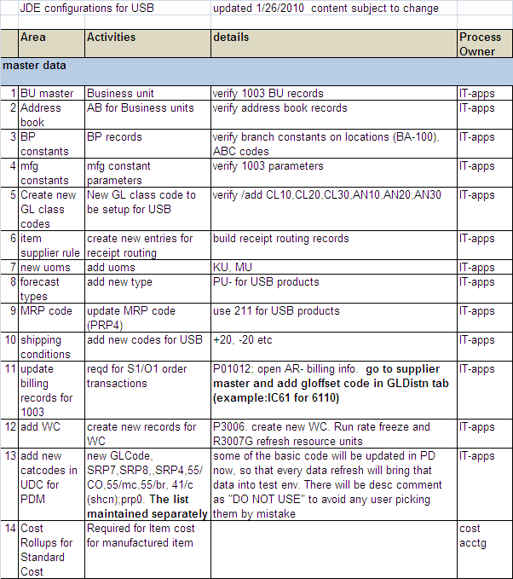

Appendix -2 changes required to batch versions/reports
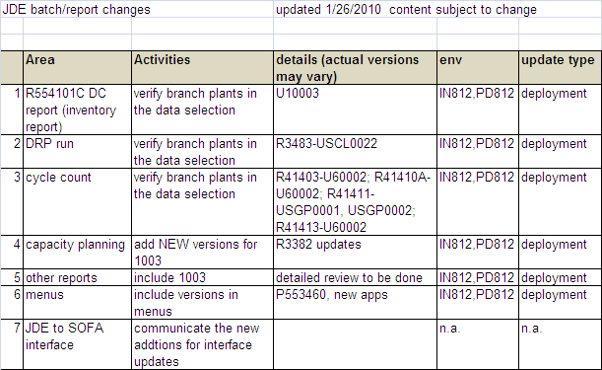

Appendix -3 RTM and high-level UAT (user acceptance testing) scope

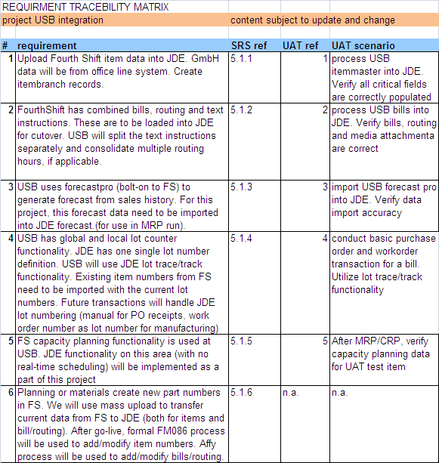

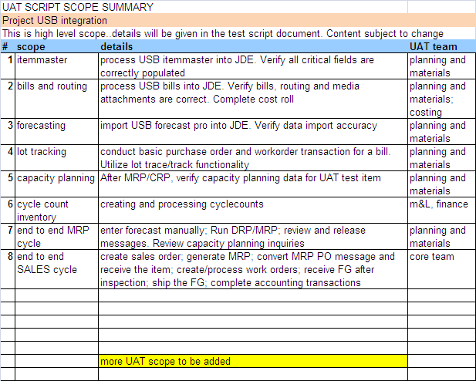

Appendix -4 JDE –ISO-QSR IMPACTED AREA TO BE MODIFIED
BUSINESS AREA | QSR IMPACTS
Plan to build | 820.181 device master record  820.70 production and process controls  820.140 handling  820.150 storage  820.160 distribution
Order to collect | 820.160 distribution  820.198 complaint files
Procure to pay | 820.50 purchasing contracts
Quality assurance | 820.80 receiving, in-process and finished device acceptance
Inquiry to resolution | 820.170 installation  820.160 distribution  820.198 complaint files  820.200 servicing
Electronic records | Title 21 CFR Part 11 – QA records  Title 21 CFR Part 11 – audit trails-record changes  Title 21 CFR Part 11 – security-authorized role based access
Electronic signatures | Title 21 CFR Part 11 – QA records requiring signatures
Procedures | Title 21 CFR Part 820.40– JDE procedures

